**TASK 1: DRAW THE BLOCK DIAGRAM OF THE CPU ALONG WITH THE CONFIGURATION OF EACH PERIPHERAL**

**AIM:** To identify the peripherals of a computer

**Software Requirement:** No Software Required.

**Hardware Requirement:** Desired Configuration for the above task is

* System unit
* CPU
* Mother Board
* FDD
* CD ROM Drive
* HDD
* Ethernet Card
* Monitor, Keyboard, Mouse & Speakers

**Safety Precautions:**

1. Beware of electrostatic discharge (ESO)
2. Build computer on a hard surface, away from concepts.
3. Wear shoes and the short sleeved cotton wear.
4. Use Phillips, head screw driver.
5. Keep the components away from moisture.
6. Avoid using pressure while installing.

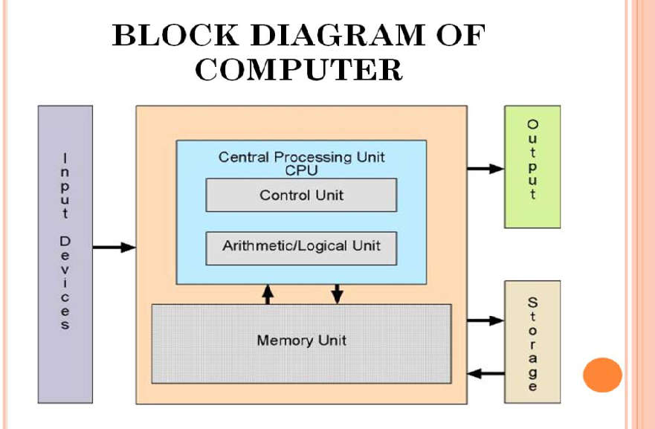

**Peripherals of a computer:**

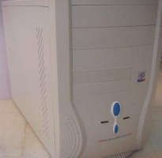

### Cabinet:

* + It is used to install all hardware devices like(mother board, SMPS,HDD, CD Rom, FDD)
  + It has Start, Restart Button, Led’s, Audio and USB Connecters are available at front side.

### Monitor:

* + Monitor of a computer is like a television screen.
  + It displays text characters and graphics in colors or in shades of grey.
  + The monitor is also called as screen or display or CRT (cathode ray tube). In the monitor the screen will be displayed in pixels format.

### Key Board:

1. **800 by 600 pixels**
2. **1024 by 768 pixels**

* 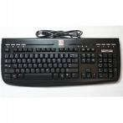Key board is like a type writer, which contains keys to feed the data or information into the computer
* Keyboards are available in two modules. These are
  + standard key board with 83-88 keys
  + enhanced key board with 104 keys or above

### Mouse:

* + 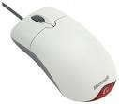Every mouse has one primary button (left button) and one secondary button (right button).
  + The primary button is used to carry out most tasks, where as secondary button is used in special cases you can select commands and options

### Printer:

* + A device that prints images (numbers, alphabets, graphs, etc…) on paper is known as Printer.
  + We have different types of printers to take printouts. These are as follows:

1. Dot matrix printer
2. Inkjet printer

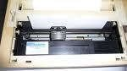 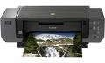

## Speakers:

* + Speakers make your system much more delightful to use entertain you while you are working on computer

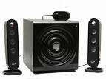

1. **Scanner:** Scanner used to scan images and text.

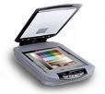

## System board/Motherboard

* + This is the major part of the PC hardware
  + It manages all transactions of data between CPU peripherals.
  + which holds the Processor, Random Access Memory and other parts, & has slots for expansion cards
  + It is rectangle shape

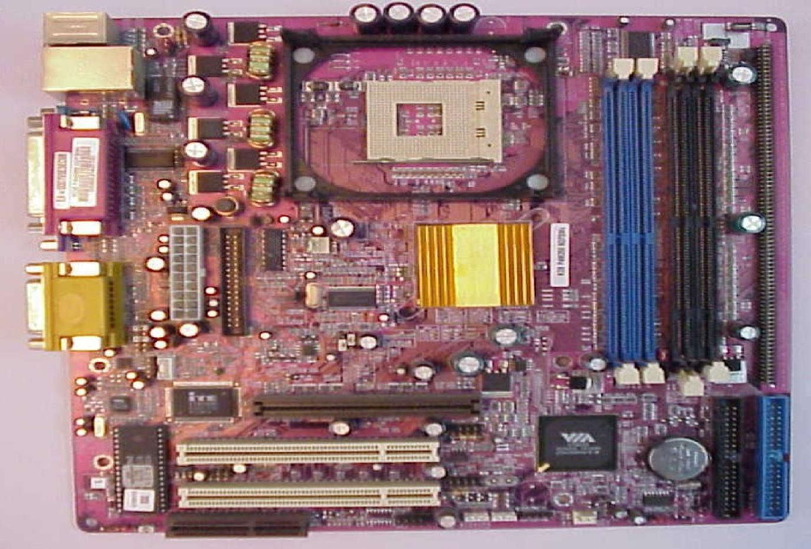

## Socket 478:

It use 478 – PIN MICROPGA package it is used installing CPU It is square type design.

## CPU

* + The central processing unit contains the heart of any computer, the processor. The processor is fitted on to a Mother Board. The Mother Board contains various components, which support the functioning of a PC.
  + 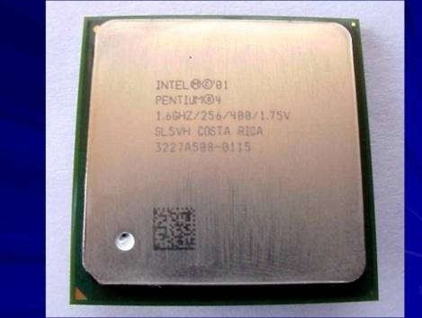It is brain of the computer
  + It is square shape

## Ram Slots:

* + Ram slots are used to install the rams
  + It is large rectangle shape and each ending has small clips.
  + There two type ram slots
  + SD Ram ----------Two Gaps (synchronous DRAM) is a generic name for various kinds of dynamic random access memory (DRAM) that are synchronized with the clock speed that the microprocessor is optimized for. This tends to increase the number of instructions that the processor can perform in a given time.
  + DDR Ram One Gap (Double Data Rate Synchronous DRAM: A clock is used to read data from

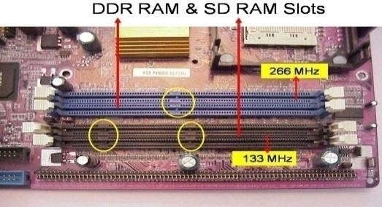a DRAM. DDR memory reads data on both the rising and falling edge of the clock, achieving a faster data rate.)

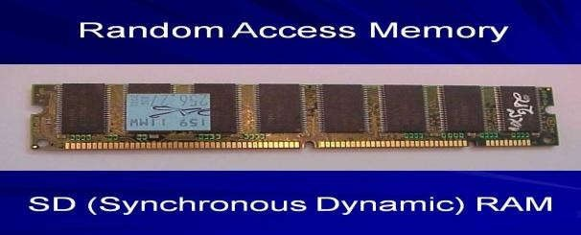

## North Bridge:

* + It is also called as controller
  + It is nearby socket 478
  + It placed middle of the mother board
  + It converts electronic signals to binary values and binary values to electronic signals

## South Bridge:

* + It is controls major components mother board and it back bone of the input out devices
  + It is communicates PCI slots, IDE-1, IDE-2, floppy connecter, BIOS chip.
  + It nearby CMOS battery

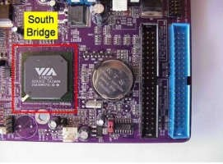

## CMOS Battery:

* + Computer is using a coin shape battery
  + It generates the clock signal and it manage system continues time.

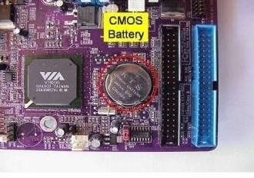

## Primary & Secondary (IDE-1 & IDE-2):

* + 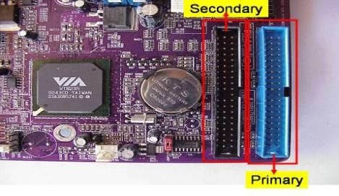It is also called as IDE-1, IDE-2.
  + It used to connecting Hard Disk Drive, CD ROM, DVD ROM.

## Input & Output ports:

* + 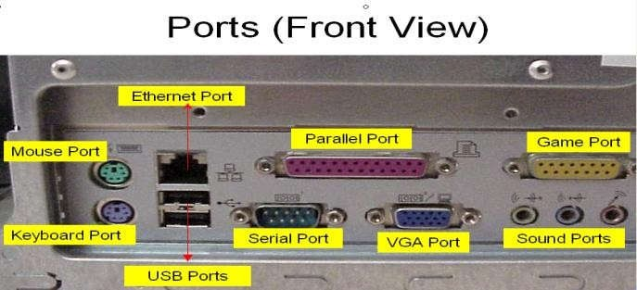IO ports are used to connecting IO device such as key boards, mouse, monitor, printer, scanner, speakers etc...

## AGP Slot & AGP Card:

* + AGP Slot is used install the AGP card.
  + AGP back view same as VGA port (15-female pins) and used to connecting the monitor’s c. This slot is above PCI slots and its color is Black or Brown

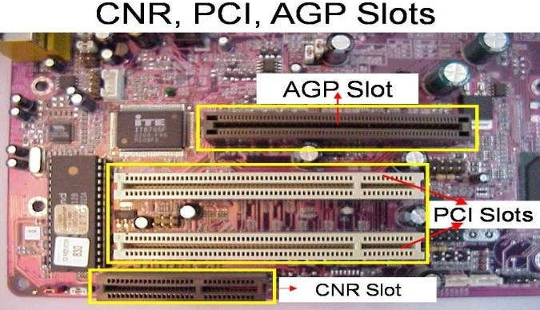 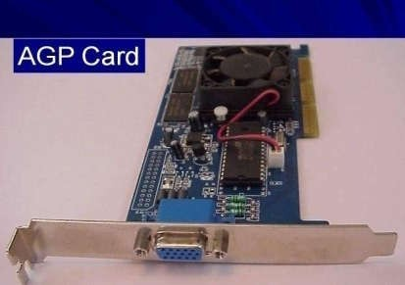

### CI Slots &PCI (Expansion) Cards:

* + PCI slots are used to install the PCI cards such as

1. LAN (Ethernet) Card---Back view Ethernet port

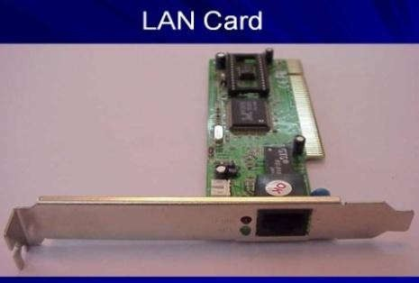

1. 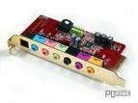Sound Card- Back view Audio pin connectors)
2. TV Tuner (Internal) Card - Dish Pin connecter
3. PCI Slots are white or yellow color
4. PCI Card has Single gap only

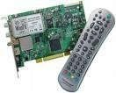

### BIOS Chip:

* + BIOS controls how the operating system and hardware wok together
  + BIOS identification is BIOS name is available on chip or mother board

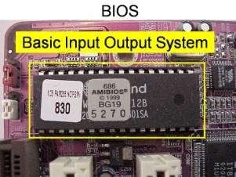

### ATX Power connecter:

* + ATX power connecter is used to connect ATX power plug (This is from SMPS)
  + It is white color and it has ATX Name is available on Mother Board
  + 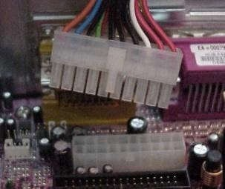ATX Power connecter has 20/24 pins available.
  + Typical ATX 1.3 power supply. From left to right, the connectors are 20-pin motherboard, 4-pin "P4connector", fan RPM monitor (note the lack of a power wire), SATA power connector (black), "Molex connector" and floppy connector.

### Floppy connecter:

* + Floppy connecter is used to connect Floppy Disk Drive.
  + This is beside of ATX power connecter and Name FDD is available on the mother board.

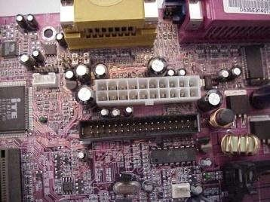

### Bus Cables or Data cables:

* + A Bus is a collection device cables are two types

of wires through which data is transmitted from one device to another

* + IDE cable: it used to connect HDD, CD ROM, DVD ROM
  + FDD cable: it used to connect FDD (braking or manufacture defecting)

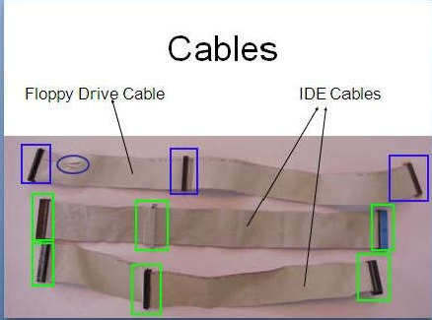

### Hard Disk Drive:

* + The hard disk drive is the main, and usually largest, data storage device in a computer
  + The operating system, software titles and most other files are stored in the hard disk drive
  + Identifications is the panel name is Hard Disk dive

### CD ROM Drive & CD-Writer:

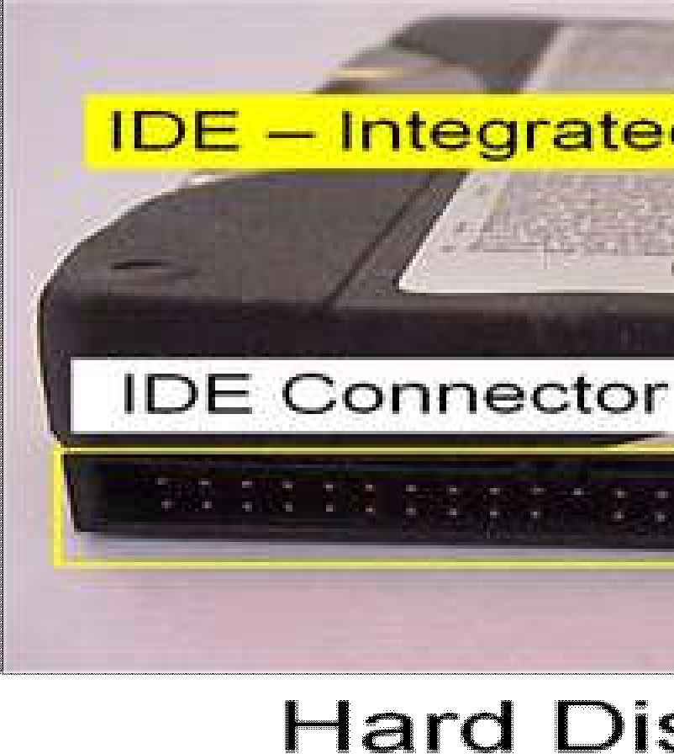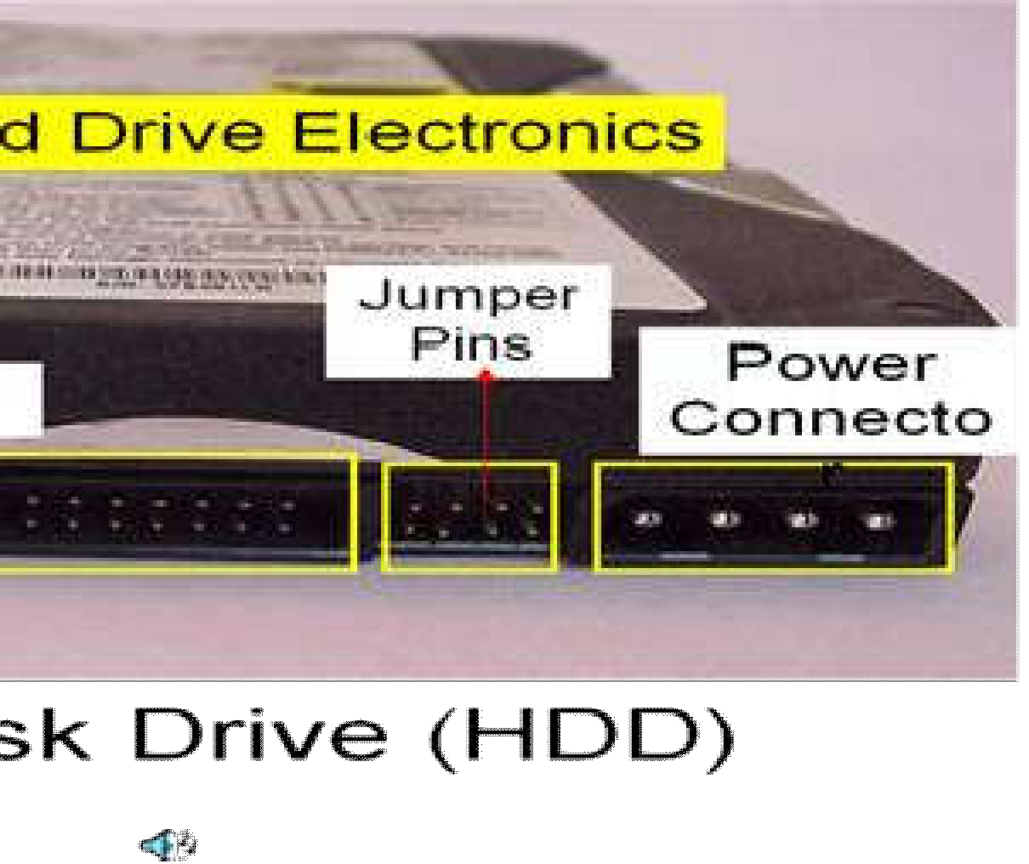

* + CD-Rom (Compact Disk Read only Memory) Drive is a device that reads the information from Compact Disks (CD).
  + CD-Writer is used to write the data into Compact Disks.
  + Identification is the panel name is CD Writer

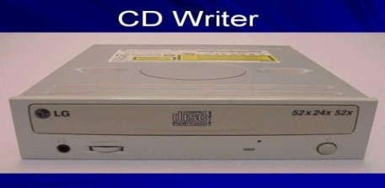

### Floppy Disk Drive:

* + The floppy disk drive is used to read the information stored in floppy disks.
  + Floppy disks also called as a diskette.
  + Identification is smaller than CD Writer.

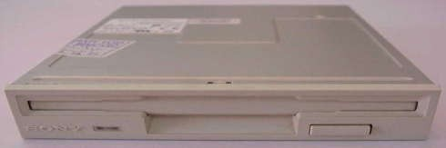

### SMPS:

* + SMPS is used to supply the power to Mother Board HDD,CD ROM, FDD
  + In SMPS holds a transformer, voltage control and fan
  + Identification is the rectangular box shape and panel name is switching mode power supply.

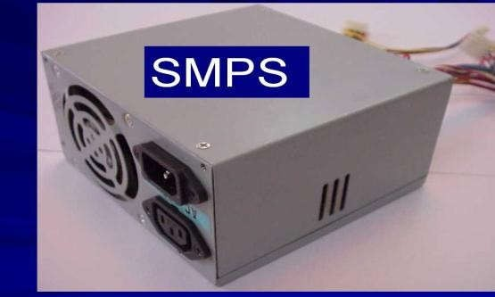

### TASK 2: ASSEMBLING & DISASSEMBLING THE SYSTEM HARDWARE COMPONENTS OF THE PERSONAL COMPUTER

1. **Setting the Cabinet ready:-**
   * Check how to open the cabinet and determine where to fix the components.
   * Determine if the case has the appropriate risers installed.
2. **Fitting the Mother board.**
   * Line up the patch on the motherboard (ps/l, USB, etc ) with the appropriate holes in the block panel I/O shield of the case.
   * Check the points where you and to install
   * Install them and make the mother board sit on them and fix screws if required.
3. **Installing the CPU**
   * Raise the small lever at the side of the socket.
   * Notice that there is a pin missing at one corner, determine the direction to fit in the processor.
   * You should not force the CPU. When inserting it. All pins should slide smoothly into the socket.
   * Lock the lever back down.
4. **Installing CPU fan**
   * Install the heat sink over it (Different type for each processor). Heat sink

/CPU fan.

1. **Fitting the RAM:**
   * The RAM must be suitable for motherboard.
   * There are currently 3 types of RAM available.
2. SD RAM.
3. DDR SD RAM.
4. RD RAM.
   * The mother board‘s chipset determines which type of RAM may be used.
5. **Installing SMPS**
6. **Installing the ATX Power Connector ATX Connectors:**
   * PS, Mouse.
   * Key board.
   * USB.
   * Parallel ( Prints )
   * Serial COM1.
   * Serial COM 2.
   * Joystick.
   * Sound.
7. **Installing the HDD and Floppy disk:**
8. Place the floppy and hard disks in their slots.
9. Leave some space above HDD to prevent heat building.
10. Check the jumper configuration.
11. Fix the screws.
12. **CD ROM Drive :**
    * CD-ROM drive is similar to installing a hard disk.
    * 1st check that the jumper configuration is correct.
    * Fix the screw.
13. **LAN Card**
14. **Connecting the ribbon Cables and Front panel connections**
    * + Attach the long end of the cable to the IDEU connector on the motherboard first. The red stripe on the IDE cable should be facing the CD Power.
15. **Final Check:**
    * Mother board jumper configurations are the settings for the processor operator.
    * Drive jumper settings, master/ slave correct?
    * Is the processor, RAM modules and plug in cards finally seated in their sockets?
    * Did you plug all the cables in? Do they all fit really?
    * Have you frightened all the screws in plug- in cards or fitted the clips?
    * Are the drive secure?
    * Have u connected the power cables to all driver?

**Powering up for the first time:**

1. Ensure that no wires are touching the CPU heat sink fan.
2. Plug your monitor, mouse and keyboard.
3. Plug in power card and switch the power supply.
4. If everything is connected as it should be
   * All systems, fans should start spinning
   * U should hear a single beep and after about 5-10 sec
   * Amber light on monitor should go green
   * You will see computer start to boot with a memory check
   * Now check front LED‘S to see if u plugged them in correctly
   * Check all other buttons
   * Power afford change any wrong settings

**TASK 4: DEBUGGING, TROUBLESHOOTING AND BASIC PREVENTIVE MAINTENANCE**

**Troubleshooting**

There are many **basic troubleshooting techniques** you can use to fix issues like this. In this lesson, we'll show you some simple things to try when troubleshooting, as well as how to solve common problems you may encounter.

**General tips to keep in mind**

There are many different things that could cause a problem with your computer. No matter what's causing the issue, troubleshooting will always be a process of **trial and error**—in some cases, you may need to use several different approaches before you can find a solution; other problems may be easy to fix.

We recommend starting by using the following tips.

* **Write down your steps**: Once you start troubleshooting, you may want to **write down**each step you take. This way, you'll be able to remember exactly what you've done and can avoid repeating the same mistakes. If you end up asking other people for help, it will be much easier if they know exactly what you've tried already.
* **Take notes about error messages**: If your computer gives you an **error message**, be sure to write down as much information as possible. You may be able to use this information later to find out if other people are having the same error.
* **Always check the cables**: If you're having trouble with a specific piece of computer **hardware**, such as your monitor or keyboard, an easy first step is to check all related cables to make sure they're properly connected.

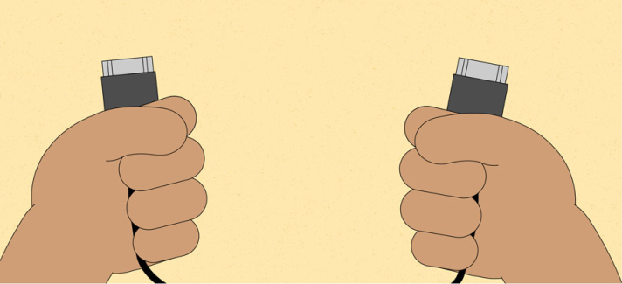

* **Restart the computer**: When all else fails, **restarting the computer** is a good thing to try. This can solve a lot of basic issues you may experience with your computer.

**Using the process of elimination**

If you're having an issue with your computer, you may be able to find out what's wrong using **the** **process of elimination**. This means you'll make a list of things that could be causing the problem and then test them out one by one to eliminate them. Once you've identified the source of your computer issue, it will be easier to find a solution.

**Scenario:**

Let's say you're trying to print out invitations for a birthday party, but the printer won't print. You have some ideas about what could be causing this, so you go through them one by one to see if you can **eliminate** any possible causes.

First, you check the printer to see that it's turned on and plugged in to the **surge protector**. It is, so that's not the issue. Next, you check to make sure the printer's **ink cartridge** still has ink and that there is paper loaded in the **paper tray**. Things look good in both cases, so you know the issue has nothing to do with ink or paper.

Now you want to make sure the printer and computer are **communicating correctly**. If you recently downloaded an**update to your operating system**, it might interfere with the printer. But you know there haven't been any recent updates and the printer was working yesterday, so you'll have to look elsewhere.

You check the printer's **USB cord** and find that it's not plugged in. You must have unplugged it accidentally when you plugged something else into the computer earlier. Once you plug in the USB cord, the printer starts working again. It looks like this printer issue is solved!

**Simple solutions to common problems**

Most of the time, problems can be fixed using simple troubleshooting techniques, like **closing** and **reopening** the program. It's important to try these simple solutions before resorting to more extreme measures. If the problem still isn't fixed, you can try other troubleshooting techniques.

**Problem: Power button will not start computer**

* + **Solution 1**: If your computer **does not start**, begin by checking the power cord to confirm that it is plugged securely into the back of the computer case and the power outlet.
  + **Solution 2**: If it is plugged into an outlet, make sure it is a **working outlet**. To check your outlet, you can plug in another **electrical device**, such as a lamp**.**
  + **Solution 3**: If the computer is plugged in to a **surge protector**, verify that it is turned on. You may have to **reset** the surge protector by turning it off and then back on. You can also plug a lamp or other device into the surge protector to verify that it's working correctly.

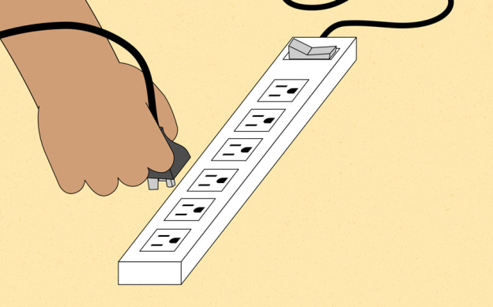

* + **Solution 4**: If you are using a **laptop**, the **battery** may not be charged. Plug the **AC adapter** into the wall, then try to turn on the laptop. If it still doesn't start up, you may need to wait a few minutes and try again.

**Problem: An application is running slowly**

* + **Solution 1**: Close and reopen the application.
  + **Solution 2**: Update the application. To do this, click the **Help** menu and look for an option to check for**Updates**. If you don't find this option, another idea is to run an online search for application updates.

**Problem: An application is frozen**

* + Sometimes an application may become stuck, or **frozen**. When this happens, you won't be able to close the window or click any buttons within the application.
  + **Solution 1**: Force quit the application. On a PC, you can press (and hold) **Ctrl+Alt+Delete** (the Control, Alt, and Delete keys) on your keyboard to open the **Task Manager**. On a Mac, press and hold **Command+Option+Esc**. You can then select the unresponsive application and click **End task** (or **Force Quit** on a Mac) to close it.

**Problem: All programs on the computer run slowly**

* **Solution 1**: Run a **virus scanner**. You may have **malware** running in the background that is slowing things down.
* **Solution 2**: Your computer may be running out of hard drive space. Try **deleting** any files or programs you don't need.
* **Solution 3**: If you're using a **PC**, you can run **Disk Defragmenter**. To learn more about **Disk Defragmenter**, check out our lesson on **Protecting Your Computer**.

**Problem: The mouse or keyboard has stopped working**

* **Solution 1**: If you're using a **wired** mouse or keyboard, make sure it's correctly plugged into the computer.
* **Solution 2**: If you're using a **wireless** mouse or keyboard, make sure it's turned on and that its batteries are charged.

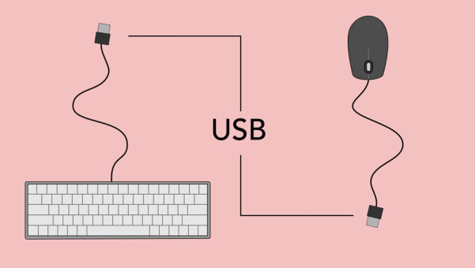

**TASK 4: EVERY STUDENT SHOULD INDIVIDUALLY INSTALL WINDOWS OPERATING SYSTEM**

**AIM**: To install Windows XP

**Software Requirement**: Windows XP Compact Disc **Hardware Requirement:**

Personal computer

**PROCEDURE:**

* 1. Keep on press the delete button and go to advanced BIOS feature [ BIOS- Basic Input Output System ]
  2. And go to boot sequence. Select first boot drivers. CD ROM and press F10 to save the bios feature. Yes and then enter. Press any key to boot from CD. Press enter to setup windows XP.

F8 = To agree the license.

* 1. Press ESC to don‘t repair the windows XP setup.
  2. Press ‗p‘to delete the previous partitions. Then press enter.
  3. Press ‗L‘to delete the partition.
  4. Press ‗C‘to create the partition in the UN partition space.
  5. Press enter to setup windows XP on the selected items.

**BASIC FILE SYSTEMS:**

FAT: File Allocation Table.

NTFS: New Technology File System. Format the create using NTFS partition.

**BASIC STEPS IN INSTALLATION:-**

1. Collecting information.
2. Dynamic update
3. Preparing installation
4. Installing windows.
5. Tracking installation

**Screen shots of windows XP Installation**

1. Insert the Windows XP CD into your computer and restart your computer. If prompted to start from the CD, press SPACEBAR. If you miss the prompt (it only appears for a few seconds), restart your computer to try again.

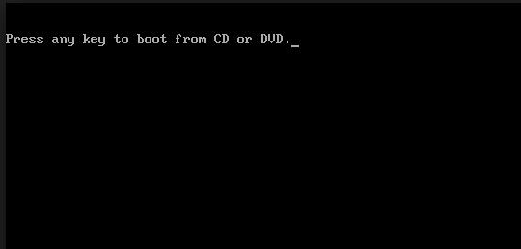

1. Windows XP Setup begins. During this portion of setup, your mouse will not work, so you must use the keyboard. On the **Welcome to Setup** page, press ENTER.

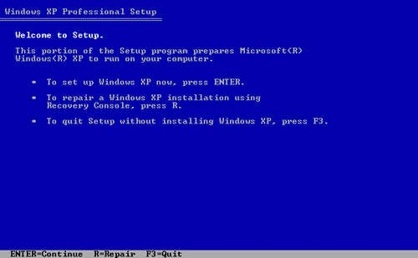

1. On the **Windows XP Licensing Agreement** page, read the licensing agreement. Press the PAGEDOWN key to scroll to the bottom of the agreement. Then press F8.

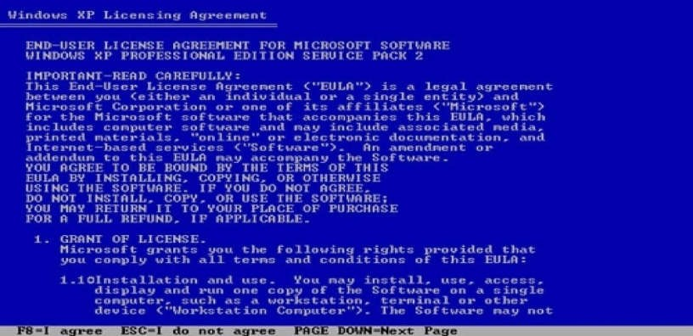

1. This page enables you to select the hard disk drive on which Windows XP will be installed. Once you complete this step, all data on your hard disk drive will be removed and cannot be recovered. It is extremely important that you have a recent backup copy of your files before continuing. When you have a backup copy, press D, and then press L when prompted. This deletes your existing data. Press ENTER to select Un **partitioned space**, which appears by default.

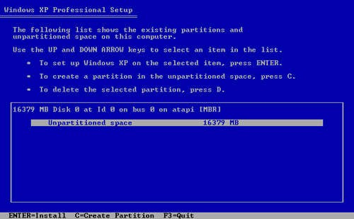

1. Press ENTER again to select **Format the partition using the NTFS file system**, which appears by default.

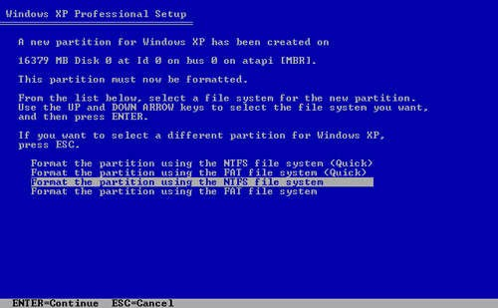

1. Windows XP erases your hard disk drive using a process called formatting and then copies the setup files. You can leave your computer and return in 20 to 30 minutes.

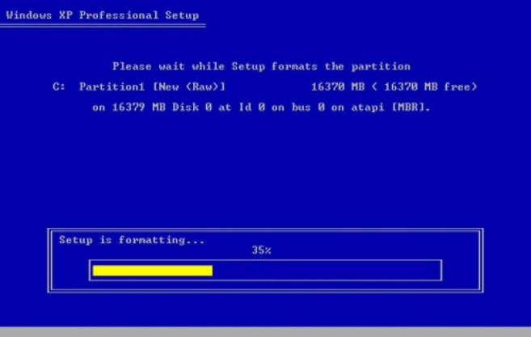

1. Windows XP restarts and then continues with the installation process. From this point forward, you can use your mouse. Eventually, the **Regional and Language Options** page appears. Click **next** to accept the default settings. If you are multilingual or prefer a language other than English, you can change language settings after setup is complete

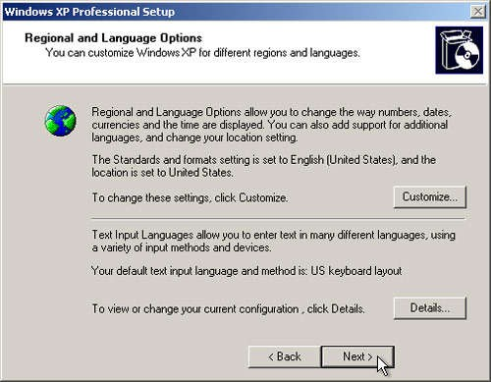

1. On the **Personalize Your Software** page, type your name and your organization name. Some programs use this information to automatically fill in your name when required. Then, click **Next**.

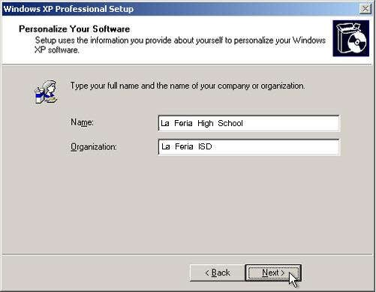

1. On the **Your Product Key** page, type your product key as it appears on your Windows XP CD case. The product key is unique for every Windows XP installation. Then, click **Next**.

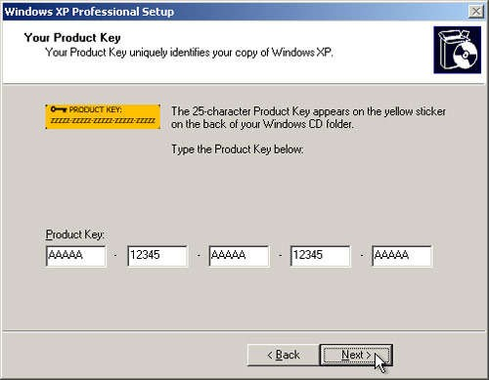

1. On the **Computer Name and Administrator Password** page, in the Computer name box, type a name that uniquely identifies your computer in your house, such as FAMILYROOM or TOMS. You cannot use spaces or punctuation. If you connect your computer to a network, you will use this computer name to find shared files and printers. Type a strong password that you can remember in the **Administrator password** box, and then retype it in the **Confirm password** box. Write the password down and store it in a secure place. Click **Next**.

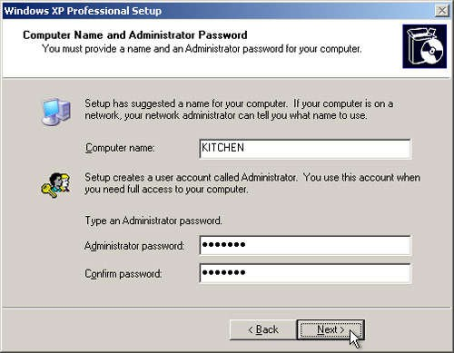

1. On the **Date and Time Settings** page, set your computer‘s clock. Then, click the

**Time Zone** down arrow, and select your time zone. Click **Next**.

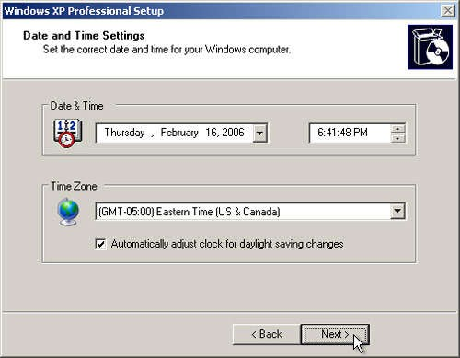

1. Windows XP will spend about a minute configuring your computer. On the

**Networking Settings** page, click **Next**.

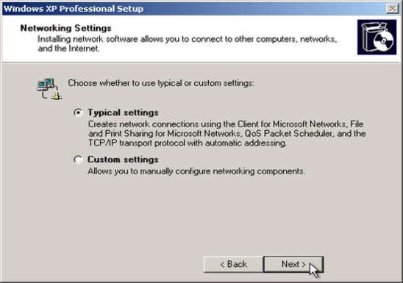

1. On the **Workgroup or Computer Domain** page, click **Next**.

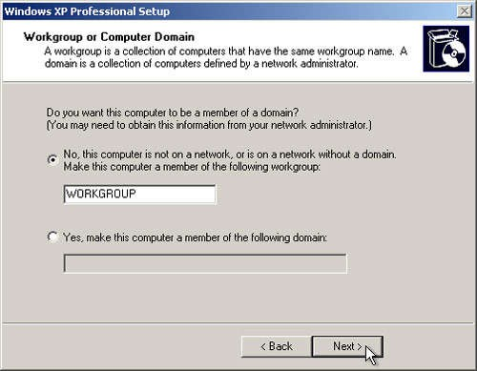

1. Windows XP will spend 20 or 30 minutes configuring your computer and will

automatically restart when finished. When the **Display Settings** dialog appears, click OK

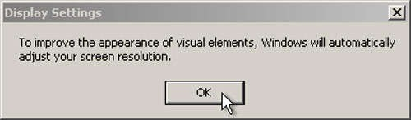

1. When the **Monitor Settings** dialog box appears, click **OK**.

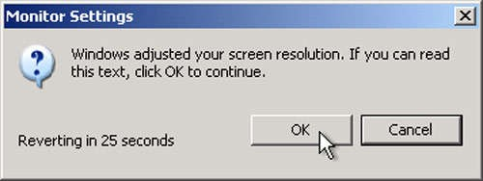

1. The final stage of setup begins. On the **Welcome to Microsoft Windows** page, click **Next**.

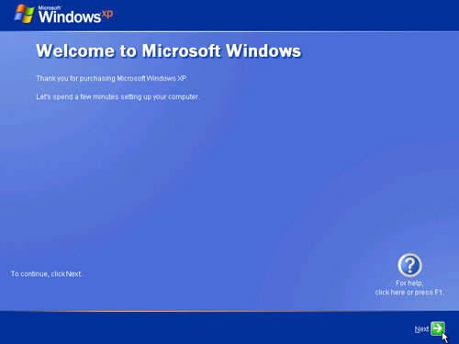

1. On the **Help protect your PC** page, click **Help protect my PC by turning on Automatic Updates now**. Then, click

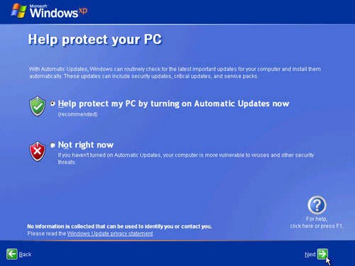

1. Windows XP will then check if you are connected to the Internet: If you are connected to the Internet, select the choice that describes your network connection on the **Will this computer connect to the Internet directly, or through a network?** Page. If you‘re not sure, accept the default selection, and click **Next**

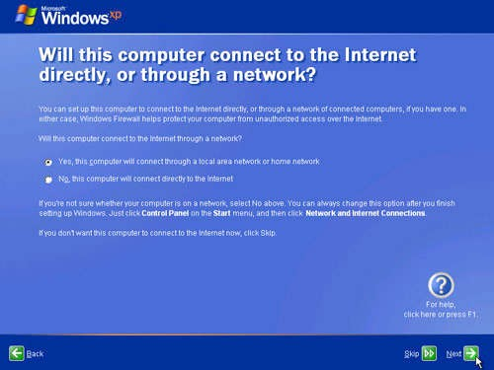

1. If you use dial-up Internet access, or if Windows XP cannot connect to the Internet, you can connect to the Internet after setup is complete. On the **How will this computer connect to the Internet?** Page, click **Skip**.

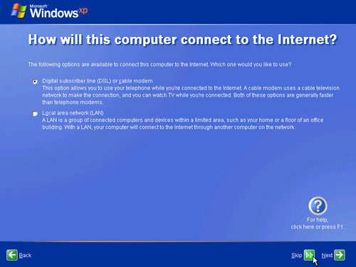

1. Windows XP Setup displays the **Ready to activate Windows?** Page. If you are connected to the Internet, click **Yes**, and then click **Next**. If you are not yet connected to the Internet, click **No**, click **Next**, and then skip to step 24. After setup is complete, Windows XP will automatically remind you to activate and register your copy of Windows XP

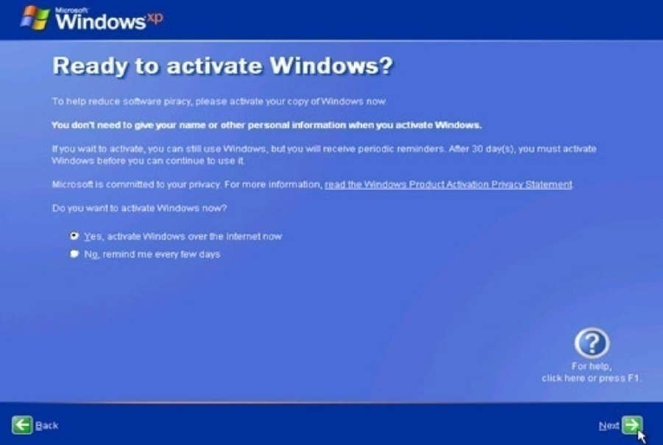

1. On the **Ready to register with Microsoft?** Page, click **Yes**, and then click **Next**.

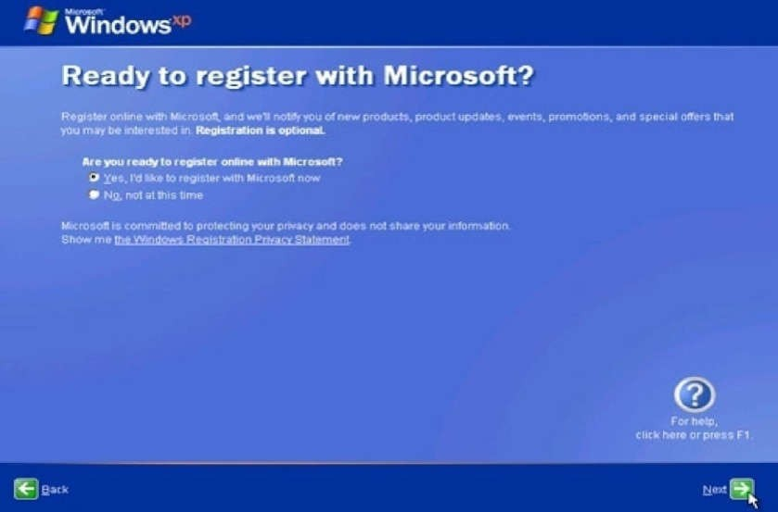

1. On the **collecting registration information page,** complete the form. Then, click Next.

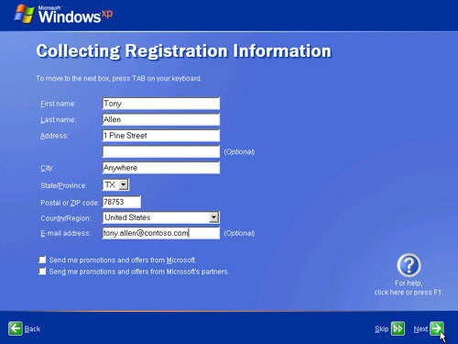

1. On the **Who will use this computer?** page, type the name of each person who will use the computer. You can use first names only, nicknames, or full names. Then click **Next**. To add users after setup is complete or to specify a password to keep your account private, read Create and customize user accounts.

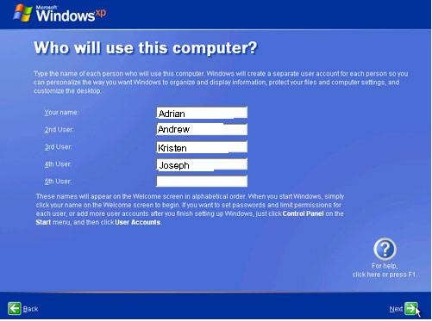

1. On the **Thank you!** Page, click **Finish**.

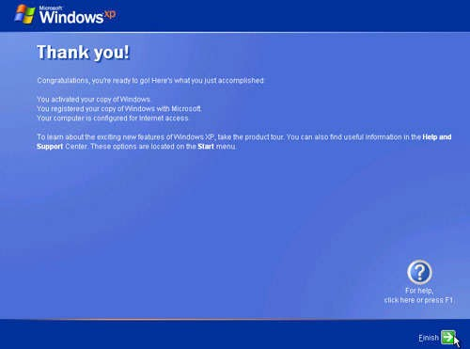

Congratulations! Windows XP setup is complete.

**TASK 5: TO INSTALL LINUX IN SYSTEM**

**Software Requirement**: Linux Compact Discs

**Hardware Requirement:** Personal computer

**PROCEDURE:**

1. **Language Selection**
   * Using your mouse select the language you would prefer to use for the installation
   * Click next to continue.

### Key Board Configuration:

* + Using your mouse select the correct layout type for the keyboard you would prefer to use for the installation and as the system default.
  + Once you have made the selection click next to continue.

### Mouse Configuration:

* + If you have a PS/2, USB or Bus mouse you do not need to pick a port and device. If you have a serial mouse, you should choose the correct port and device that your serial mouse is on.
  + The Emulate 3 buttons checkbox allows you to use a two-button mouse as if it had three buttons. If you select this check box you can emulate a third ―middleǁ button by pressing both mouse buttons simultaneously.

### Installation Type:

* + Choose the type of installation you would like to perform.
  + Your options are **Personal desktop, Workstation, Server, Custom** and

**upgrade**

### Disk partition Setup:

* + You can chose automatic partitioning or manual partitioning using **Disk Druid** of **fdisk.**
  + Automatic partitioning allows you to perform an installation without having to partition your drives yourself.
  + Automatic partitioning allows you to have some control concerning what

data is removed from your system.

* + Your options are:

 Remove all Linux partitions on this system.

 Remove all partitions on this system

# 

Keep all partitions and use existing free space.

* + To partition manually choose either Disk druid or fdisk partitioning tool.
  + Lick next once you have made your selections.

### Partitioning your system:

* If you chose automatic partitioning and did not select **Review**

skip ahead

* If you choose automatic partitioning and selected **review** you can either accept the current partition settings (click next) or modify

the setup using **Disk Druid**, the manual partition tool.

□ If you choose manual partition with disk skip ahead.

* At this point you must tell the installation program where to install Linux. This is done by defining mount points for one or more disk partitions in which Linux will be installed.

### Adding Partitions:

To add a new partition select **new** button, a dialogue box appears. Select the options and click **ok**

### Boot Loader Configuration:

Boot loader is the first software program that runs when a computer starts. The installation program provides two boot loaders **GRUB ( GR and**

**Unified Boot Loader)** which is the default and **LILO**

If you do not want GRUB as your boot loader click Change Boot Loader.

□

□

You can then choose to install LILO or choose not to install boot loader at all by clicking **Do not install boot loader** on the **change boot loader** button.

Network devices are automatically detected and displayed in **Network Devices** list,

Select a network device and click **Edit**

Here you can configure IP address and net mask of the device.

### Firewall configuration:

* + Offers firewall protection for enhanced protection.

□ A properly configured firewall can greatly increase the security of the

system.

### Time zone configuration:

You can set your time zone by selecting your computers physical location or by specifying your time zones offset from Universal Time.

### Account Configuration:

□ Allows to set Root password or user accounts

□ Root count is similar to the administrator password that you set up in Win NT.

* Click **add** button to add a new non-rot user.
* Enter the details and click **OK.**

### Packing group selection:

You can select package groups which groups components together or individual packages or a combination of the two.

**TASK 6: HARDWARE TROUBLESHOOTING: STUDENTS HAVE TO BE GIVEN A PC WHICH DOES NOT BOOT DUE TO IMPROPER ASSEMBLY OR DEFECTIVE PERIPHERALS. THEY SHOULD IDENTIFY THE PROBLEM AND FIX IT TO GET THE COMPUTER BACK TO WORKING CONDITION.**

**AIM:** Hardware troubleshooting

**Software Requirement**: No software required **Hardware Requirement:** Personal computer **Troubleshoot:-**

1. If you hit the power button & nothing happened.
   * Check all power connections.
   * Check for power on mother board.
2. If the system turns on but does not beep or begin to boot up.
   * Remove all components except motherboard/ cpu / moniter check by giving power to them

### Computer error beeps codes:

**No beep:** short, no power, bad CPU/ MD, loose peripherals.

**One beep:** everything is normal & computer posted tax.

**Two beeps:** post / CMOS error.

**One long beep One short beep:** Motherboard problem.

**One long beep two short beep:** video problem. **One long beep 3 short beeps:** video problem. **3 long beeps:** keyboard error.

**Repeated long beep:** memory error.

**Continuous high- low beeps:** CPU overheating

**TASK 7: SOFTWARE TROUBLESHOOTING: STUDENTS HAVE TO BE GIVEN A MALFUNCTIONING CPU DUE TO SYSTEM SOFTWARE PROBLEMS. THEY SHOULD IDENTIFY THE PROBLEM AND FIX IT TO GET THE COMPUTER BACK TO WORKING CONDITION.**

**AIM:** Software troubleshooting

**Software Requirement**: Malfunctioning CPU due to system software

**Hardware Requirement:** Personal computer

**PROCEDURE:**

**Error messages encountered during boot before Windows loads**

Ensure that your computer BIOS settings are correctly configured to the hardware that is installed in your computer

### Error messages while windows loading

1. If you have recently installed or changed something that could have caused normal windows to stop loading, try loading the last known good configuration
2. If you are unable to get into Normal windows and believe that removing or uninstalling a program or changing a setting may help enable you to get into windows, boot the computer into windows XP safe mode
3. If your computer has worked fine in the past but recently has been experiencing the issue you are encountering run the system restore option to restore the computer to an earlier date

### Other error messages that occur while windows is loading or after windows is loaded

* 1. If error occurs but windows still loads, verify no issues or conflict exits in device manager
  2. Ensure that if programs are loading automatically that these errors are not associated with these programs
  3. Make sure Windows XP is up to date by checking Microsoft windows update page
  4. If your computer has virus protection installed make sure that it is up to date and that no virus are being detected
  5. If your computer has worked fine in the past but recently has been experiencing the issue you are encountering run the system restore option to restore the computer to an earlier date

**TASK 8: ORIENTATION & CONNECTIVITY BOOT CAMP: STUDENTS SHOULD GET CONNECTED TO THEIR LOCAL AREA NETWORK AND ACCESS THE INTERNET. IN THE PROCESS THEY CONFIGURE THE TCP/IP SETTING. FINALLY STUDENTS SHOULD DEMONSTRATE HOW TO ACCESS THE WEBSITES AND EMAIL.**

**AIM:** To learn Local Area Network and access the Internet. In the process they configure the TCP/IP setting. Finally students should demonstrate, to the instructor, how to access the websites and email

**Software Requirement**: Local Area Network to access the Internet **Hardware Requirement:** Personal computer **THEORY:**

The internet is a worldwide, publicly network of interconnected computer networks

### LOCAL AREA NETWORK:

LANs are privately owned networks with in a single building or campus of up to few kilometers in size.

### WIDE AREA NETWORK:

A WAN is a network that connects computers across a large geographic area such as a city or country

### TCP/IP(Transmission Control Protocol/Internet Protocol):

Collection of methods used to connect servers on the internet and to exchange data.

### HTML (Hyper Text Markup Language):

The coding used to control the look of documents on the web

### HTTP (Hyper Text Transfer Protocol):

Part of a url that identifies the location as one that uses HTML

### IP (Internet Protocol):

A format for contents and addresses of packets of information sent over the internet

### IP ADDRESS:

An identifier for a computer or device on a TCP/IP network

### SEARCH ENGINE:

A program that searches documents located on the Internet for keywords or phrases entered by a person browsing the net.

### Internet Connection requirements:

* TCP/IP protocol
* Client Software
* ISP Account

### Means of communication to the net:

* telephone Modem
* Ethernet
* ISDN(Integrated Services Digital Network)
* DSL(Digital Subscriber Line)
* Satellite.

**PROCEDURE:**

1. Go to **start>control Panel**
2. open **Network Connections**
3. Click **create a new connection** and then click **next**
4. The new connection wizard window opens , click **next**

to continue

1. Choose one of the options in the next dialog box
2. Choose one of the three options in the next dialog box

□ If you do not have an internet account click **choose from a list of ISPs** and then click **next**

* If you have an account click Set up my connection manually
* If you have a CD from the ISP click use the CD I got from an ISP and then click next

1. Follow the next steps as per the option you selected. **TEST DATA**: No Test data for this Experiment **ERROR:** No Errors for this Experiment

**RESULT:** In this way we can learn surfing the web

**TASK 9: WEB BROWSERS, SURFING THE WEB: STUDENTS CUSTOMIZE THEIR WEB BROWSERS WITH THE LAN PROXY SETTINGS, BOOKMARKS, SEARCH TOOLBARS AND POP UP BLOCKERS. ALSO, PLUG-INS LIKE MACROMEDIA FLASH AND JRE FOR APPLETS SHOULD BE CONFIGURED**

**AIM:** To learn to surf the web

**Software Requirement**: Local Area Network to access the Internet

**Hardware Requirement:** Personal computer

**THEORY:**

□Web browser provides the means to the searching and also helps to Download the web content.

* Web browsers support most of the famous Internet Protocols like HTTP, FTP.
* Common file formats a browser accepts are HTML
* Well known browsers natively support a variety of other formats in addition to HTML such as JPEG,PNG,GIF image formats
* Different web browsers available in the market are:

# Mosaic

# Netscape

# Mozilla

# Opera

# Lynx

# Safari

Each web browser is built-in with the support of Internet Bookmarks which serve as a named anchor – primarily to URLs. The primary purpose of this book mark is to

easily catalog and access web pages that the web browser user has visited or plans to visit, without having to navigate the web to get there.

### Pop-up Blockers:

Pop-ups are a form of online advertising on the WWW intended to attract the attention of the users. These pop ups are hosted on the web sites which are frequently visited by the netizens. These pop ups are activated when these web sites open a new web browser window and there by displaying the advertisements.

### Plug-ins:

A plug-in is a software component program that interacts with a main application to provide a better integration of the media. The basic difference between application programs and plug-ins is that multimedia files are launched in a separate window where as in plug-ins multimedia play in the browser window.

### Few famous plug -ins are:

* Apple Quick Time
* Macromedia flash
* Microsoft Media Player
* Adobe Shockwave
* Sun Microsystems Java Applet

**PROCEDURE: LAN**

**Proxy Settings:**

* select **tools** menu in Internet Explorer
* Select **Internet Options**
* Select **Connections**
* You end up in two options

**Dial-up and virtual network settings**

### LAN setting

* The selection at this step is dependent on the kind of connection you are trying to

□configure. They are:

 **Dial-up modem connection**

 **LAN connection**

#  DSL or Cable modem

**TASK 10: SEARCH ENGINES & NETIQUETTE: STUDENTS SHOULD KNOW WHAT SEARCH ENGINES ARE AND HOW TO USE THE SEARCH ENGINES. USAGE OF SEARCH ENGINES LIKE GOOGLE, YAHOO, ASK.COM AND OTHERS SHOULD BE DEMONSTRATED BY STUDENT.**

**AIM:** To know what search engines are and how to use the search engines. **Software Requirement**: Local Area Network to access the Internet **Hardware Requirement:** Personal computer

**THEORY:**

**Search engine:**

A search engine can be defined as a web site with tools which help you to find information on the internet

### Function of a search engine:

You can find anything from a schedule of White house tours to instructions for removing stains from clothes.

### Limitations:

Search engines visit web sites only several weeks. Search engines cannot see information in other data bases later on.

On the internet a search engine is a coordinated set of programs that includes: A spider (crawler or bot) that goes to every page or representative pages on every web site that wants to be searchable and reads it , using hypertext links on each page to discover and read site‘s other pages.

### Pros:

* You can select the search terms
* You can use the same search terms with multiple search engines
* You can change search terms as much as you wish
* You will normally receive numerous links

**Cons:**

EX:

* Its fast
* There are so many different search engines it may be difficult to choose
* You will normally receive too many links often making it difficult to identify the most relevant sites.
* The vast majority of links may be only marginally relevant or altogether irrelevant
* Alta Vista
* Ask Jeeves
* Google
* Lycos Etc...

### Meta Search Engines:

Meta search engines or ―metacrawlersǁ don‘t crawl the web themselves. Instead they search the resources of multiple search engines by sending a search to several search engines at once aggregating the result.

### Pros:

* + You only need to use one search tool which is time- efficient
  + You only need to learn how to use one search engine reducing learning curve
  + You benefit from the difference among several search tools at once

### Cons:

* Meta search services may not be able to leverage each individual search engines full range of query tools resulting in less refined searches
* You can not personally select the search engines queried by Meta search services.

**TASK 11 : CYBER HYGIENE: STUDENTS SHOULD LEARN ABOUT VIRUSES ON THE INTERNET AND INSTALL ANTIVIRUS SOFTWARE. STUDENT SHOULD LEARN TO CUSTOMIZE THE BROWSERS TO BLOCK POP UPS, BLOCK ACTIVE X DOWNLOADS TO AVOID VIRUSES AND/OR WORMS.**

**AIM:** To learn various threats on the internet and configure the computer to be safe on the internet.

**Software Requirement**: Antivirus Software **Hardware Requirement:** Personal computer **THEORY:**

### Antivirus:

Antivirus software is a program that either comes installed on your computer or that you purchase and install yourself. It protects your computer against most viruses, worms, Trojan horses and other unwanted invaders that can make your computer sick.

### Firewall:

A firewall is a special software or hardware designed to protect a private computer network from unauthorized access. A firewall is a set of related programs located at a network gateway server which protects the resources of the private network from users from other networks.

**PROCEDURE:**

**Installing Symantec antivirus for Windows:**

* Insert Symantec antivirus CD into your CD drive
* Double click on the Symantec-setup.exe
* The installer will open
* Click **next** to proceed
* License agreement will open. Click **I accept the terms of the license agreement** and then click **next.**
* Follow the instruction on the screen to complete the installation.

**Get Computer Updates:**

### Click start> settings>control panel

* Click **Automatic Updates** icon to open Automatic Updates dialog box
* Check the box **Keep my computer up to date**
* Choose a setting
* Click OK

### Block Pop ups:

* In the IE open **tools>pop-up blocker**
* Click on **Turn on Pop- up blocker**

### Windows Firewall:

□Go to **Start>control panel>Network and Internet Connections >windows firewall**

□ In the general tab check the **On(recommended)** box

□ If you don‘t want any exceptions check on **Don’t allow exceptions box**

**TEST DATA**: No Test data for this Experiment **ERROR:** No Errors for this Experiment **RESULT:** Antivirus is installed in the system

**TASK 12 :DEVELOP HOME PAGE: STUDENT SHOULD LEARN TO DEVELOP HIS/HER HOME PAGE USING HTML CONSISTING OF HIS/HER PHOTO, NAME, ADDRESS AND EDUCATION DETAILS AS A TABLE AND HIS/HER SKILL SET AS A LIST.**

**AIM:**

To create a your web page using HTML

**Software Requirement**: Notepad, Any web browser **Hardware Requirement:** Personal computer **CODE:**

<html>

<head>

<title> details</title>

</head>

<body>

<img src="photo.jpg" height=100 width=100>

<h1> NAME : Radha</h1>

<h1><pre> Address:

H.NO.1-241/29,

Kukatpally, Hyderabad-500062

</pre></h1>

<h1> Educational Details</h1>

<table border=1>

<tr>

<th>Course </th>

<th>Name of the Institutation</th>

<th>Year of Pass</th>

<th>Percentage</th>

</tr>

<tr>

<td>M.Tech(CSE)</td>

<td>Vasavi College of Engineering</td>

<td>2011</td>

<td>81%</td>

</tr>

<tr>

<td>B.TEch(CSE) </td>

<td>CVR Engineering College</td>

<td>2009</td>

<td>75%</td>

</tr>

<<tr>

<<td>Intermediate </td>

<td>Sri Chaitanya</td>

<td>2005</td>

<td>89%</td>

</tr>

<td>SSC</td>

<td>Little Buds High School</td>

<td>2003</td>

<td>85%</td>

</tr>

</table>

<h1>Technical Skills:</h1>

<ultype=disc>

<li>Programming Languages : C, JAVA</li>

<li>Operating Systems : Windows </li>

<li>Database Systems : Oracle</li>

<li>Web Technologies

</ul>

</body>

</html>

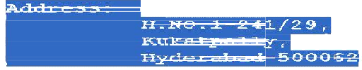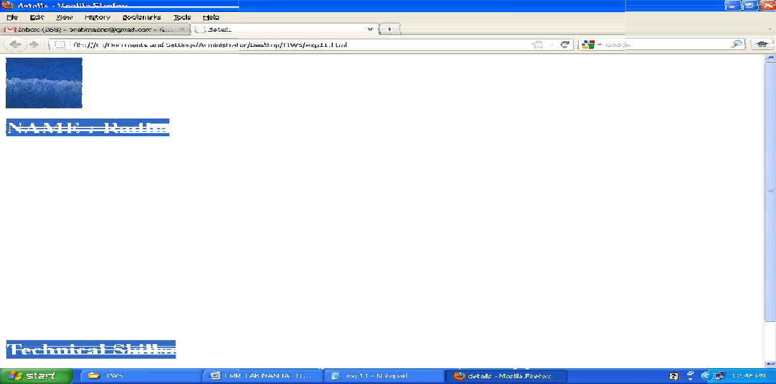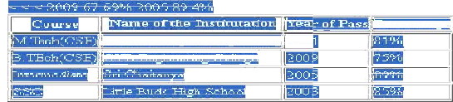

: HTML</li>

**TASK 13: Create Windows 10 Bootable USB Drive**

First, make sure you download the Windows 10 Technical Preview by joining the [**Windows Insider Program**](http://windows.microsoft.com/en-us/windows/preview), as explained in [**this article**](https://www.groovypost.com/news/install-test-windows-10-technical-preview/). Also, make sure you’re using a [**USB drive**](https://amzn.to/38bf4T3) at least 4 GB for the 32-bit version and 8 GB for the 64-bit version.

One of the first cool things about Rufus is that no installation is necessary, which means you can stick it on a network location or another external drive to run it. When you run it, setting it up is simple. Select the USB drive you want to use, select your partition scheme – it’s worth noting that Rufus also supports a bootable UEFI drive.

Then select the disc icon next to the ISO drop-down and navigate to the location of your official Windows 10 ISO.

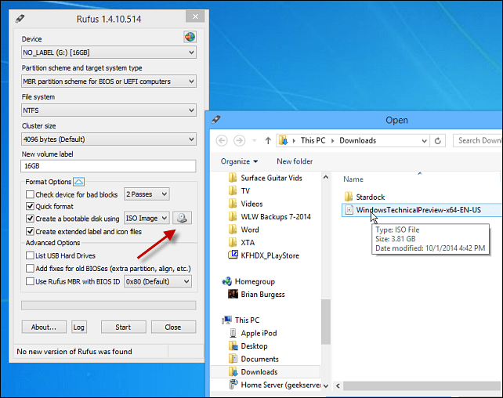

After that, click Start, and you should be good to go within minutes. If you want to be extra careful, check the option to check the device for bad blocks. I didn’t do that, and my bootable drive turned out fine.

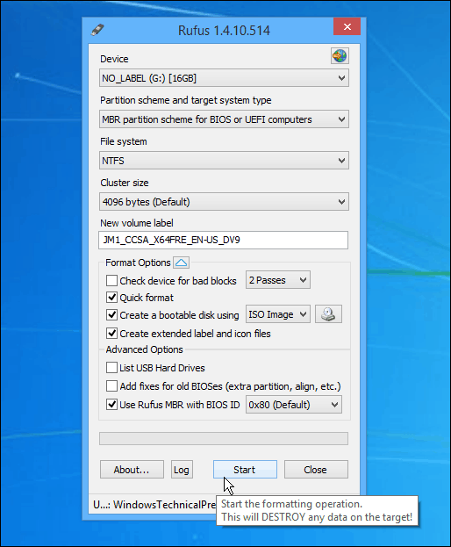

**TASK 14: IDENTIFYING NETWORK COMPONENTS AND DEVICES (HUB, SWITCH AND ROUTER)**

**HUB**

Hub is considered as one of the basic icons of networking devices which is implemented at the physical layer and hence connects networking nodes physically together. Hubs are fundamentally utilized in networks that use twisted-pair cabling to connect nodes.

[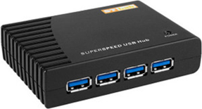](https://blogmedia.testbook.com/blog/wp-content/uploads/2021/06/hub-984280b3.png)

They are created in a way to send the packets to the other appended devices without editing any of the transmitted packets received. They work as pathways to direct electrical signals to travel along. They transmit the information without caring of fact that the data packet is destined for the device linked or not.

**Hub falls into two categories**

**Active Hub**

They are more advanced than the passive hubs. They not only facilitate the path for the data signals, but they also regenerate, concentrate and strengthen the signals before transmitting them to their destinations. Active hubs are also called ‘repeaters’.

**Passive Hub**

They are similar to the point contact for the wires to build in the physical network. They have no work of modifying the signals.

**Ethernet Hubs**

It is a device linking various Ethernet devices together and makes them carry on the functions as a single device. They are different in speed in terms of data transfer rate. Ethernet utilizes the so-called Carrier Sense Multiple Access with Collision Detect (CSMA/CD) to control Media access. The Ethernet hub connects in a “half-duplex” mode where the possibility of data collision is inevitable most of the time.

**Switches**

Switches work as the connection points for an Ethernet network. Just like in the hub, devices in switches are linked to them through twisted-pair cabling. But the variation shows up in the manner both the devices, hub and a switch, take the data. Hub works by sending the data to all the ports on the device whereas a switch transfers it only to that port that is linked to the destination device.

[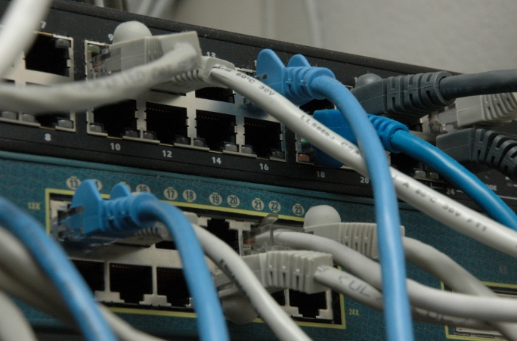](https://blogmedia.testbook.com/blog/wp-content/uploads/2021/06/switches1-a9778f07-scaled.jpg)

A switch does so by having in-built learning of the MAC address of the devices linked to it. Since the sending of data signals is predefined in a switch, therefore the network performance is consequently effective. Switches work in a “full-duplex” mode where nodes can send and receive data from the switch simultaneously unlike in half-duplex mode.

**Bridges**

A bridge is a type of computer networking component that builds the connection with the other bridge networks that are present on the same protocol. It is implemented at the Data Link Layer of the OSI Model and links the different networks together and creates communication between them. It combines two local-area networks; two physical LANs into bigger logical LANs or two segments of the already existing LAN that use the same protocol.

Apart from creating larger networks, bridges are also utilized to segment bigger networks into smaller portions. The bridge performs this by placing itself between the two portions of two physical networks and managing the flow of the data between them.

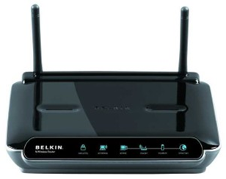**Routers**

Routers are network layer components and are particularly categorized as Layer- 3 components of the OSI Model. They work on logical addressing information in the Network header of a packet like IP Addresses.

A router is utilized to implement bigger complex networks by complex traffic routing. It has the authority to connect dissimilar LANs on the same protocol. It also has the authority to restrict the flow of broadcasts. A router mainly comprises a hardware component or a system of the computer which has multiple network interfaces and routing software.

**Gateways**

Gateway is a device that is implemented to combine multiple networks and transmits packets from one network to the other network. Working as the ‘gateway’ in the middle of different networking systems or computer programs, a gateway forms a link between them.

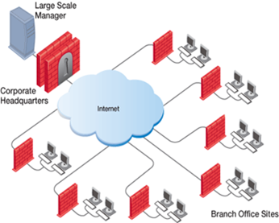

It facilitates computer programs, either on the same device or on a different device to share information across the network via protocols. A router is also a kind of gateway because it interprets data from one network protocol to another.

**Network Card**

Network cards are sometimes referred to as Network Interface Cards (NICs). These are hardware components that link a computer with the network. They are installed on the motherboard. They work to develop a physical connection of the network to the computer. Computer data is transformed into electrical (analog) signals sent to the network via Network Interface Cards.

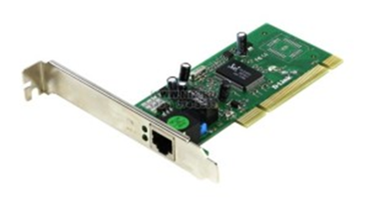

They are also able to manage some important data-transformation functions. These days’ network cards are software controlled unlike in older days when drivers were required to configure them.

**Modems**

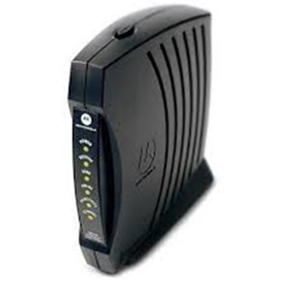A modem is a device that transforms computer-generated digital signals into analog signals to enable their traveling through phone lines. The ‘modulator-demodulator or modem may work as a dial-up for LAN or connect to an ISP.

Modems can be both external, as in the device which correlates to the USB or the serial port of a computer, or proprietary elements for handheld smart appliances and other devices, and as internal, in the form of add-on expansion cards for computer systems and PCMCIA cards for laptop computers.

The design of a modem varies for both the external and internal modem. In internal